I. Use Case Description
Use Case Name | CareAir: Explainable Reasoning for Healthcare Ventilation Compliance
Use Case Identifier | HVCC-05
Source | Center for Architecture Science and Ecology, Rensselaer Polytechnic Institute
Point of Contact | Ahosan Habib, habiba5@rpi.edu  Nipun Deelaka, pathin@rpi.edu  Andy Cheng, chengy11@rpi.edu  Carina Liu, liuc17@rpi.edu
Creation / Revision Date | 10/02/2026 (Version-5)
Associated Documents | - ANSI/ASHRAE/ASHE Standard 170-2025, Ventilation of Health Care Facilities  - CDC, Guidelines for Environmental Infection Control in Health-Care Facilities -the open source of the numeric thresholds actually encoded.  - ASHRAE Standard 223P, Semantic Data Model for Analytics and Automation Applications in Buildings  - DOE / PNNL Prototype Building Models - Hospital, New York variant (EnergyPlus).  - Prior OE course project: indoor-environment-manager (OE 2022), Chung, Rook and Jacoby-Cooper - reviewed for reuse (Section X)

II. Use Case Summary
Goal | Enable a hospital infection preventionist or facilities engineer to determine whether critical care spaces currently satisfy the ventilation requirements that their clinical designation imposes; to identify which air-handling equipment is responsible when a space falls out of compliance or would fall out of compliance during a planned outage; and to keep both the determination and its history correct when a space is re-designated to a different clinical use.
Requirements | R1. Represent the clinical function of a space as a ROLE the space plays over a period, not as a permanent subclass of the space. Ventilation requirements follow clinical function and hospital spaces are re-designated in service.  R2. Represent ventilation requirements declaratively - pressure relationship and minimum air change rate - as data associated with a clinical designation, carrying units, a staleness window and a citation to the published source of the threshold, rather than hard-coded in application logic.  R3. Represent the air distribution topology - which equipment connects to what, through which connections, carrying which medium - so that the relation between an air handling unit and the spaces it serves is derived by traversal rather than asserted.  R4. Associate sensor observations with the space and the property they measure, carrying units.  R5. Produce compliance determinations by query and inference over the model, with no space-specific procedural code, so that designating a new space or re-designating an existing one changes what is evaluated with no change to code or queries.  R6. Retain provenance for every determination: which observation, at what time, compared against which requirement, and the published source from which the threshold was taken.  R7. Retain the designation history of a space, so that a determination made while the space held a previous designation remains interpretable and is not silently re-evaluated under the requirement that replaced it.  R8. Operate read-only. The system reports and explains; it never actuates equipment and must never become a dependency of a life-safety control loop.
Scope | In scope for this assignment:  • Two clinical designations: airborne infection isolation and operating room..  • Two requirement kinds: room pressure relationship (positive / negative / neutral) and minimum air changes per hour.  • Designation as a time-bounded role, and the re-designation of a space from one clinical use to another.  • One air-handling system, and the terminal units and spaces downstream of it.  Out of scope, deferred as term extensions:  • Quantification of energy savings and the penalty of over-ventilation excluded because it requires a thermal-energy model and an energy price signal, and the compliance question does not depend on either: a space either meets its pressure and air-change requirement or it does not, whatever that costs to achieve.  • Fault detection and diagnosis, and control actions excluded by requirement R8, which keeps the system read-only. Diagnosis asserts a cause; this project asserts only whether a requirement is met and which evidence supports that. Crossing into actuation would also make the system a dependency of a life-safety control loop, which R8 forbids.  • Water, medical gas and electrical systems excluded because each carries its own requirement vocabulary and none bears on the two requirement kinds in scope, pressure relationship and air change rate. Including them would enlarge the term list without exercising any new reasoning.  • Patient data of any kind. Excluded on both ethical and modelling grounds: no competency question requires it, and admitting protected health information would place the model under HIPAA for no analytical gain. The model describes spaces and equipment only.  • Selecting among jurisdictional variants excluded because choosing between variants requires a model of legal authority - which code is adopted in which jurisdiction, as of when - which is a separate problem. Pre-condition P6 instead fixes a single requirement set as the evaluation context, so the reasoning can be demonstrated without that machinery.  • Every trigger except T1. Excluded because T2 to T4 each require running infrastructure - a scheduler, a live observation stream, a change-detection service - that this project is not building. Each is documented in the Triggers row because it shapes the design, but only T1, a user-initiated request, is implemented.
Priority | High within the project.
Stakeholders | Primary: infection preventionists, who are accountable for containment in isolation and protective-environment spaces; hospital facilities and plant operations engineers, who own the air systems.  Secondary: surgical and nursing staff occupying the affected spaces; the hospital compliance officer preparing for Joint Commission and CMS survey; patients, particularly immunocompromised and airborne-isolation patients, who bear the clinical consequence of a containment failure; hospital administration, carrying regulatory and financial risk.
Description | Building codes are written for people to read. There is no machine-checkable form of them, so compliance is established by a person walking the building with a clipboard and the reasoning behind a determination is not recorded anywhere. This use case takes the sharpest instance of it - hospital ventilation, where the consequence of being wrong is clinical rather than financial - and builds the smallest version of it that can be completed.  Hospitals are the one building type in which ventilation performance is a clinical matter rather than only a comfort or energy matter. ASHRAE Standard 170 assigns each space a required pressure relationship and a minimum air change rate according to what clinically happens in it: an airborne infection isolation room must be held negative with respect to the corridor so that contaminated air cannot escape, while an operating room must be held positive so that unfiltered air cannot enter.  The requirement follows the clinical function of the space. The ability to satisfy it follows the physical air distribution topology. The evidence that it is satisfied comes from live sensor readings. These three bodies of knowledge live in three unconnected places: the clinical space program, the mechanical model and the building management system. A compliance question cannot be answered without joining all three.  This use case proposes an ontology that joins them, so that the question is asked once and answered by inference. The principal actors are the infection preventionist and the facilities engineer. The system reports compliance state and explains it by naming the responsible equipment and the clause that makes the requirement binding.  One claim underlies the whole use case. That a particular air handling unit serves a particular isolation room is not declared in any system of record - it is a consequence of how the ductwork was built. It must be derived by traversing a typed connection graph and the determination that follows must carry its own justification: the observation it rests on, the threshold it was compared against and the clause that makes that threshold binding. Deriving the relation and justifying the answer are what separate this from a database query and they are why the problem needs an ontology rather than a schema.
Actors / Interfaces | PRIMARY (invoke the use case and benefit from the result):  • Infection preventionist - asks whether containment is currently being maintained.  • Facilities engineer - asks which equipment is responsible and what a planned outage would affect.  SECONDARY (acted upon by the system):  • 223P knowledge graph - spaces, equipment, connections, media, observable properties.  • Clinical space classification - assigns each space its ASHRAE 170 space type.  • ASHRAE 170 requirement encoding - thresholds with units and clause citations.  • Building management system / BACnet and IoT sensor API - differential pressure and airflow observations.  • IFC-LD building model - source of spaces, storeys and containment relationships.  • SPARQL endpoint and SHACL validation engine - evaluate constraints and return results.
Pre-conditions | P1. A 223P model of the nursing unit exists and has passed SHACL validation.  P2. Every space within scope carries a clinical space type classification. A space with no clinical type cannot be evaluated and must be reported as such rather than skipped.  P3. The air distribution topology is represented continuously from the air handling unit through terminal units to the domain spaces served, with each connection typed by medium.  P4. Differential pressure sensors are associated with the spaces they observe and with the property they measure and observations carry QUDT units.  P5. Requirements for the in-scope designations are encoded as data with threshold, unit, pressure relationship, staleness window and source citation.  P6. A single requirement set is fixed as the evaluation context.  P7. The requesting user is authenticated and authorised to view facility data.
Post-conditions | Q1. Every in-scope space carries a compliance determination of compliant, non-compliant or indeterminate.  Q2. Each determination carries the observation and timestamp that produced it, the threshold compared against, and the clause from which that threshold derives, so the result can be reproduced and audited.  Q3. Indeterminate results - arising from a missing sensor, a stale observation, or an unclassified space - are reported explicitly and are never silently treated as compliant. The system fails visibly rather than optimistically.  Q4. For a planned-outage query, the affected spaces are returned together with the requirement each would violate and the connection path establishing the dependency.
Triggers | T1 is the only trigger in scope for this project, on review feedback. T2 through T4 are documented because each shapes the design, but each also requires running infrastructure - a scheduler, a live stream - that this project is not building.  T1. IN SCOPE. User-initiated (external). A preventionist requests current compliance state, typically before a patient placement decision; an engineer submits a planned-outage query.  T2. DEFERRED. Scheduled (temporal). Periodic re-evaluation maintains a standing compliance state.  T3. DEFERRED. Observation-driven (internal). An observation crossing its threshold, or ageing beyond the staleness window, changes the compliance state of a space.  T4. DEFERRED. Model-change (internal). Reclassification of a space, modification of the topology or adoption of a new edition of the standard invalidates existing determinations and triggers re-evaluation. Because requirements are inherited from space type rather than attached per room, a reclassification alone is sufficient to change what is checked.
Performance Requirements | Standing compliance state returned interactively, target under five seconds for a nursing unit; downstream dependency traversal is a planning query, target under ten seconds.  Evidence recency is evaluated at request time, under T1. When a request is served, the most recent observation for each space is compared against a staleness window that is a configurable property of the requirement, not a constant in the query; an observation older than that window yields indeterminate rather than a stale determination. Because scheduled re-evaluation (T2) and observation-driven re-evaluation (T3) are deferred, the system holds no standing compliance state between requests, and this revision therefore specifies no re-evaluation interval. The fifteen-minute interval given in the previous revision described T2 and has been removed.  Sizing: one nursing unit is on the order of thirty spaces, one AHU, forty terminal units, one hundred points; the representation must extend to a full campus (~10,000 spaces) without redesign.  Maintainability: thresholds, units, and citations are data in the graph, so a change of adopted edition is a data update rather than a code change. The system is advisory and read-only and must never become a dependency of a life-safety control loop.
Assumptions | Sensor readings are trusted as reported; sensor fault detection is out of scope.A space holds at most one clinical designation role at any one instant, and every designation role has a start; an open-ended role is current.A single requirement set is in force for the facility for the whole period modelled.  For initial development the DOE Prototype Hospital supplies topology and zone volumes, with observation streams derived from an EnergyPlus run; the sensor-binding pattern is validated separately against a real live feed from an instrumented office.  DECISION (staleness), taken on review feedback. Staleness is modelled at both levels rather than one. A VentilationRequirement carries a staleness window, which expresses the clinical tolerance for how old evidence may be for that kind of space. A sensor binding separately carries an expected reporting frequency, which expresses how often that instrument is supposed to report. The two are independent and both are checked: an observation older than the requirement window yields INDETERMINATE, while an instrument that has missed its own expected frequency is flagged as a suspect binding even when its last reading is still inside the clinical window. Holding both lets the system report which of the two conditions failed, which a single combined attribute could not.  DECISION (extensibility), taken on review feedback. Where a modelling choice is open, this project resolves it in favour of later extension rather than present simplicity, because the team intends to carry the work past the end of the semester. Accordingly occupancy state is modelled as an index on the requirement rather than as two separate requirements, so that an unoccupied-setback module can be added additively instead of as a rewrite.
Open Issues | Terminology harmonisation across the team. The space-type labels in the extracted building data and the space types named in the requirement encoding do not currently match, and five people are about to write terms for five modules. This is the subject of Assignment 4 and is recorded here because it blocks module composition, not because it is unsolved in principle.

III. Usage Scenarios

Scenario 1 - Patient placement under airborne precautions

Maria is an infection preventionist at a 300-bed hospital. At 14:30 she is notified that a patient with suspected pulmonary tuberculosis is being admitted and requires an airborne infection isolation room on the fourth-floor east unit. Four rooms on that unit are designated AII. Maria needs to know, before the patient is moved, which of them are actually holding the negative pressure differential that their designation requires - not which were commissioned correctly two years ago. She opens the compliance view for the unit. Each designated room is listed with its current determination, the measured differential, the threshold it was measured against, the timestamp of the reading, and the published clause the threshold comes from. Two rooms are compliant. One is failing at −0.8 Pa against a required 2.5 Pa, and the air handling unit serving it is named alongside it, so the referral to facilities carries the equipment with it. One is indeterminate: its sensor last reported at 12:05, beyond the staleness window on the requirement, and the system will not call a room compliant on a reading that old. Maria places the patient in a compliant room, forwards the failing room with its serving equipment, and treats the indeterminate room as unusable until it is verified.

Scenario 2 - Planning an air handler outage

David is a facilities engineer. A filter bank on AHU-3 is due for replacement, a six-hour job that requires taking the unit offline. Before he schedules it he must know which spaces with a directional pressure requirement depend on that unit - because losing containment in an occupied isolation room is a reportable event, and losing positive pressure in an operating room mid-procedure is worse.
The information he needs is not written down anywhere. Which rooms AHU-3 serves is a consequence of ductwork, recorded only in mechanical drawings that may not reflect twenty years of modification. Today the answer is reconstructed by a senior technician from memory and a drawing set. With the proposed system David names the equipment and the system traverses the air distribution topology downstream, returning the spaces reached, the requirement each would violate during the outage, and the connection path that establishes the dependency. He also asks which units in the building serve the most pressure-critical spaces, and uses that ranking to plan the rest of the year’s maintenance so the highest-consequence work happens when those rooms are empty.

Scenario 3 - Converting a patient room to isolation use

Admissions of a communicable respiratory infection have risen and the unit needs more isolation capacity than it was built with. Maria designates patient room 4E-20 for airborne isolation use, effective immediately. She records the designation; she does not write a rule, and no one edits a query.
The system closes the period of the room’s previous designation and opens a new one from the stated instant. From that moment the room inherits the requirement that attaches to airborne isolation - negative with respect to the corridor, and a minimum air change rate - and is evaluated against it like any other isolation room. The room’s earlier determinations are untouched: they remain attached to the designation that was in force when they were made, so a compliant result recorded in August is still a true statement about a general patient room and is not silently reinterpreted as a failed isolation room.
The first evaluation under the new designation returns NON-COMPLIANT, and the reason is not a sensor reading. Traversing the room’s connections shows no exhaust path capable of establishing a negative relationship at all, so the system reports the missing capability and the serving equipment rather than a measured value - distinguishing a room that is not currently holding the condition from a room that cannot hold it. That distinction is what tells Maria whether to wait or to call facilities. This is the case the project’s own instance data reproduces: the patient room designated for isolation in the DOE prototype computes a negative relationship only once a dedicated exhaust fan is present in the model, and computes neutral or positive without one.

IV. Basic Flow of Events
The normal course below is written for Scenario 1, in which a preventionist asks for the current compliance state of a nursing unit. All three scenarios share its shape - resolve what the space is, resolve what that obliges, gather the evidence, decide, and return the decision with its justification - but they diverge in the middle, and each therefore has its own step table.
Scenario 2 replaces steps 3 to 6. The request names a piece of equipment rather than a unit, and the system traverses the connection graph downstream from it, resolves the designation of every space it reaches, and keeps only those whose requirement carries a directional pressure relationship. No observation is read at all, because the question is about a future outage rather than the present state; the evidence is the topology, not a sensor.
Scenario 3 adds three steps in front. The request is a re-designation rather than a query, so the system first closes the period of the designation role in force and opens a new one from the stated instant, and only then runs the evaluation steps of Scenario 1 against the requirement the space has just inherited. The determinations already recorded stay attached to the designation that was in force when they were made.
In all three the final step returns the determination together with the evidence behind it, and in none of them does the system write to the building. The alternate flow in Section V applies to all three, because any of them can reach the point where an observation is required and find it missing or stale.

Basic / Normal Flow of Events: Scenario 1 - Patient placement under airborne precautions
Step | Actor (Person) | Actor (System) | Description
1 | Infection preventionist | — | Requests current compliance state for nursing unit 4-East.
2 | — | Compliance service | Retrieves all spaces contained in the unit from the knowledge graph.
3 | — | Reasoner | Infers the clinical type of each space and the VentilationRequirement inherited from that type, with threshold, unit, and clause citation.
4 | — | Observation store | Returns the most recent differential-pressure observation per space, with timestamp and unit.
5 | — | Compliance service | Compares each observation against its inherited threshold and assigns compliant, non-compliant, or indeterminate.
6 | — | Graph / topology query | For each non-compliant space, traverses connections upstream to identify the serving air-handling equipment.
7 | — | User interface | Presents each space with determination, measured value, threshold, governing clause, timestamp, and serving equipment.
8 | Infection preventionist | — | Selects a compliant room for placement and forwards the non-compliant room to facilities.

Basic / Normal Flow of Events: Scenario 2 - Planning an air handler outage
Step | Actor (Person) | Actor (System) | Description
1 | Facilities engineer | — | Names the equipment to be taken offline and the proposed outage window.
2 | — | Graph / topology query | Locates the equipment and its outlet connection points in the graph.
3 | — | Graph / topology query | Traverses connections carrying air downstream through terminal units to the domain spaces reached, repeating until no further connection is reachable.
4 | — | Reasoner | Resolves the designation role in force for each space reached and the requirement it inherits.
5 | — | Compliance service | Retains only the spaces whose requirement includes a directional pressure relationship, and the connection path establishing each dependency.
6 | — | User interface | Returns the affected spaces, the requirement each would violate during the outage, and the path.
7 | Facilities engineer | — | Schedules the outage for a window in which the affected spaces are unoccupied.

Basic / Normal Flow of Events: Scenario 3 - Converting a patient room to isolation use
Step | Actor (Person) | Actor (System) | Description
1 | Infection preventionist | — | Designates a named space for a different clinical use, effective from a stated instant.
2 | — | Compliance service | Closes the period of the designation role currently in force. Determinations already made remain attached to it and are not modified.
3 | — | Compliance service | Opens a new designation role for the space, effective from the stated instant.
4 | — | Reasoner | Inherits the VentilationRequirement of the new designation. No query and no code changes; the space is now evaluated as any space holding that designation is evaluated.
5 | — | Observation store | Returns the most recent observation of each newly required property, with timestamp and unit.
6 | — | Compliance service | Assigns a determination under the new designation and records the evidence behind it.
7 | Infection preventionist | — | Accepts the space for the new use, or refers it to facilities for modification.

V. Alternate Flow of Events
Out-of-band condition: the evidence required for a determination is missing or stale. This is the most common abnormal case in practice, and the behaviour is deliberately conservative - absence of evidence is never treated as evidence of compliance.

Alternate Flow of Events
Step | Actor (Person) | Actor (System) | Description
4a | — | Observation store | Returns no observation for a space, or one older than the staleness window defined on the requirement.
4b | — | Compliance service | Assigns INDETERMINATE. The space is never marked compliant on the basis of a stale or absent reading.
4c | — | Compliance service | Records the reason: no sensor bound, sensor not reporting, or space not classified.
4d | — | User interface | Surfaces indeterminate spaces separately and prominently rather than merging them with compliant ones.
4e | Infection preventionist | — | Treats the space as unusable for placement..

VI. Use Case and Activity Diagram(s)
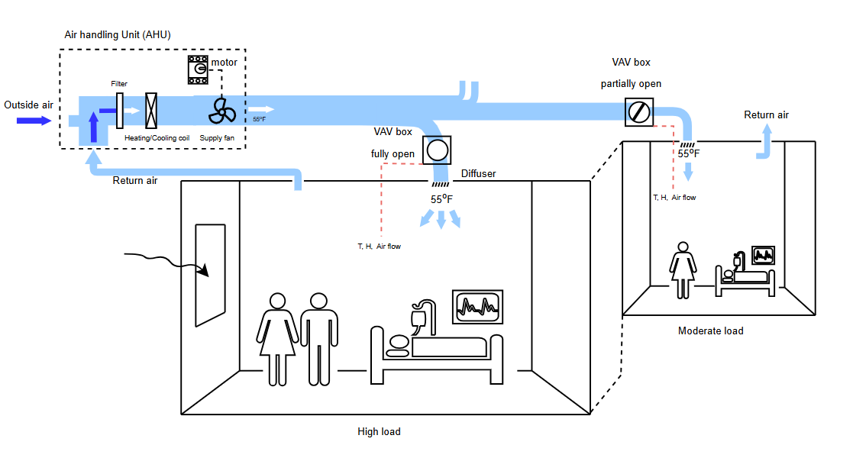
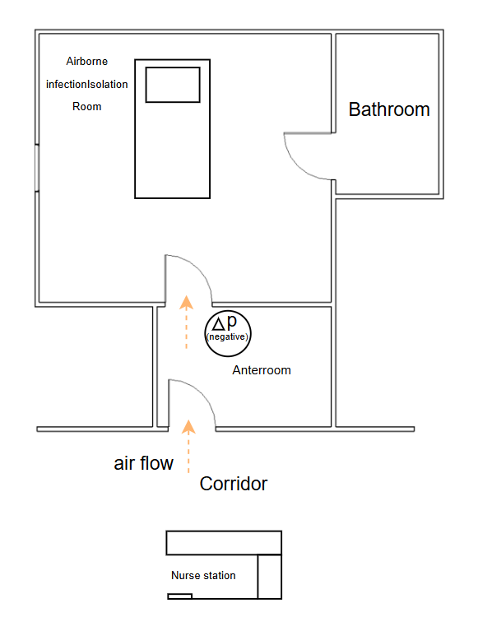
An instance of a hospital scenario

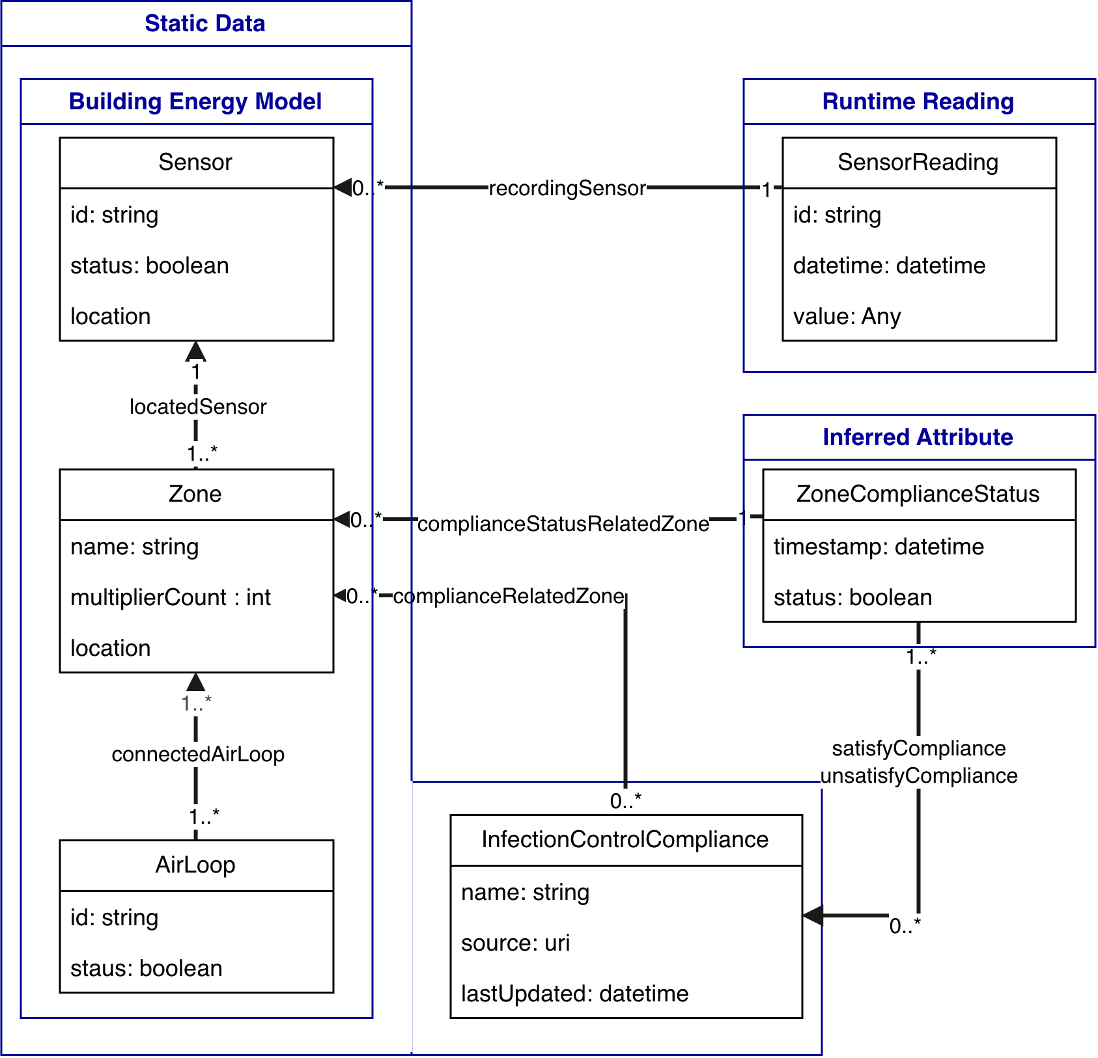

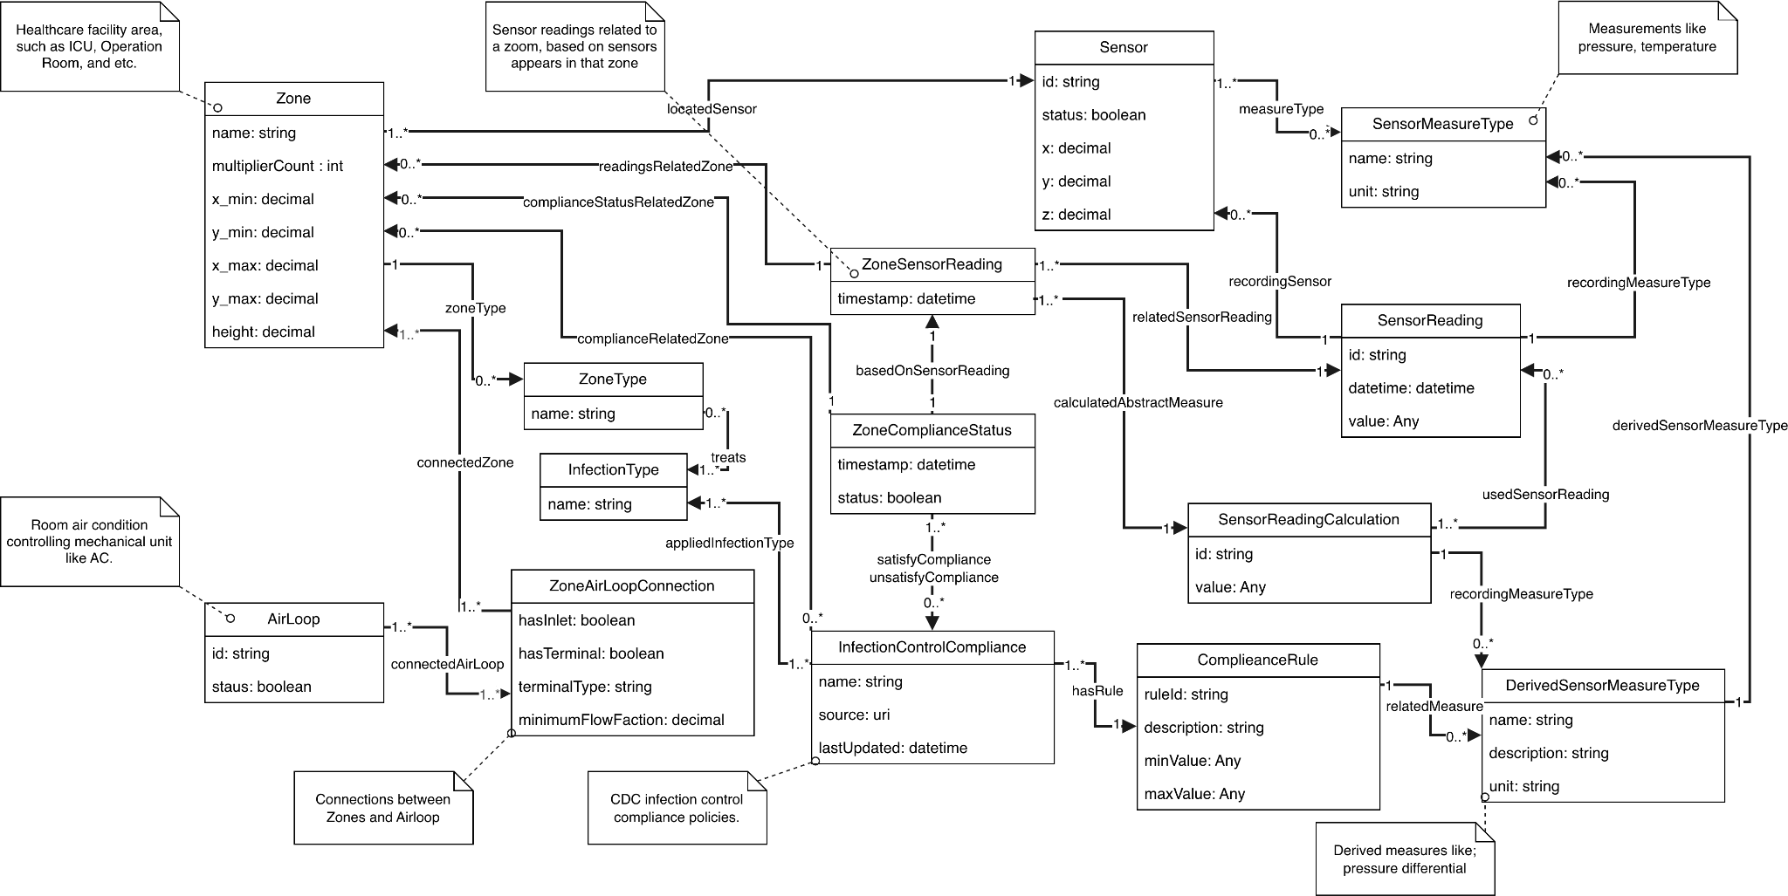

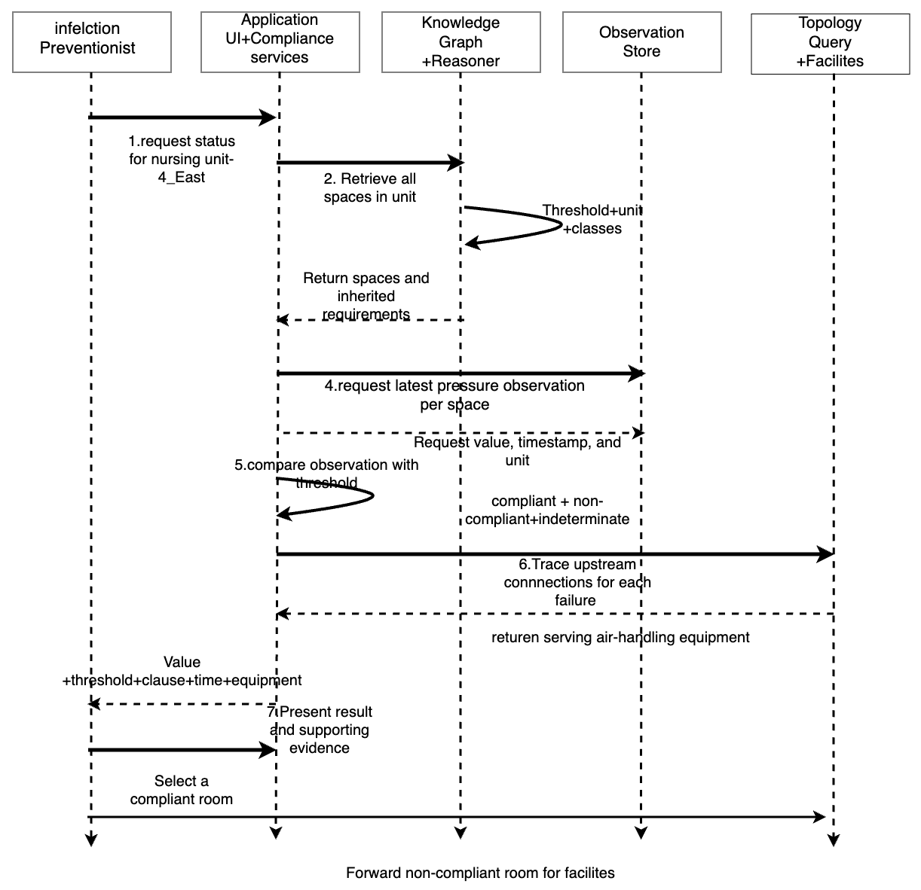
Sequence diagram for the Scenario 1 normal flow
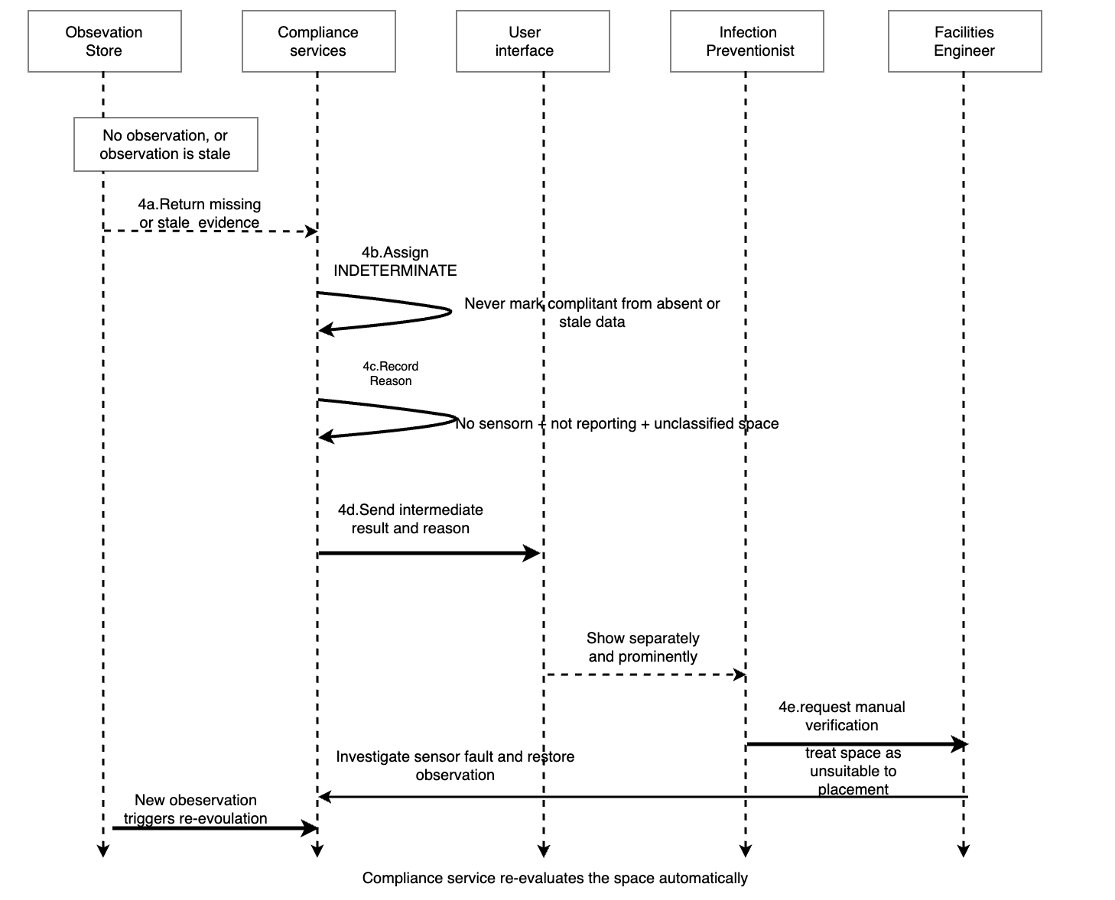
Sequence diagram for the alternate flow
VII. Competency Questions

Questions are grouped by usage scenario, and there are six of them across the three scenarios. The three exercise different reasoning, which is why the set is not interchangeable: Scenario 1 is classification and constraint checking with provenance; Scenario 2 is traversal and aggregation over topology; Scenario 3 is temporal - it tests whether the model keeps its history straight when the thing being described changes. An ontology answering only one of the three would be incomplete for this use case. Each question below gives the question, a concrete example answer, and the specific representation choices that let the ontology produce it.

Scenario 1 - Patient placement
CQ 1.1 - Which airborne infection isolation rooms are currently failing their required negative pressure differential?
Example answer:
Room 4E-12 is out of compliance. ASHRAE 170 requires airborne infection isolation rooms to be held negative with respect to the adjacent corridor, at a differential of at least 2.5 Pa. The most recent observation for 4E-12 is −0.8 Pa, taken at 14:20 on 5 September 2026. The space is served by AHU-3 through terminal unit VAV-412. Rooms 4E-14 and 4E-16 are compliant at −3.1 Pa and −2.9 Pa respectively.
How the ontology produces this answer:
- Each room is an s223:DomainSpace and is additionally classified as an AirborneInfectionIsolationRoom, a subclass of the locally introduced HealthcareSpace.
- A VentilationRequirement individual is associated with that space type through isGovernedBy, and carries requiredPressureRelationship (Negative), minimumPressureDifferential (2.5), a qudt:unit of PA, and a citation to the ASHRAE 170 clause it derives from.
- A differential pressure sensor is linked to the room by s223:observes and to the property it measures by s223:hasProperty, so the reading is attached to a typed quantity with units rather than to a bare point name.
- Reasoning: the requirement is inherited by every instance of the space type rather than attached room by room, so a newly commissioned isolation room is checked correctly the moment it is classified. Comparison of the observed value against the inherited threshold yields the compliance state, and provenance is retained by recording which observation and which requirement version produced it.

CQ 1.2 - For a room reported as non-compliant, what evidence produced that determination, and can the determination be reproduced?

Example answer: Room 4E-12 was determined NON-COMPLIANT at 14:32 on 21 September 2026. The determination rests on a differential pressure observation of −0.8 Pa recorded at 14:20 by the sensor bound to that room. It was compared against a minimum differential of 2.5 Pa negative, which the room inherits from the airborne isolation designation it has held since 3 August 2026. The threshold is recorded with its source: CDC, Guidelines for Environmental Infection Control in Health-Care Facilities, with the page cited. Re-running the evaluation against the same observation returns the same determination.

How the ontology produces this answer:

- A determination is an individual in the graph, not a boolean column. It is the thing that carries provenance, and it is what makes the answer auditable.
- The threshold is never a bare number. It carries a QUDT unit and a citation to the published document it was taken from, so a reader can go and check it. Nothing in the project reproduces a copyrighted table; only the handful of numeric facts for the two designations in scope is encoded, from open publications.
- Reasoning: this is requirement R6. Reproducibility follows from the determination naming its inputs - the same observation and the same requirement yield the same result, and a determination made last month can be re-examined without re-running anything.

Scenario 2 - Planning an air handler outage
CQ 2.1 - If AHU-3 is taken offline for maintenance, which isolation rooms will lose containment?
Example answer:
Three spaces lose their required directional airflow. Rooms 4E-12 and 4E-14 are airborne infection isolation rooms requiring negative pressure; room 4W-03 is a protective environment room requiring positive pressure. All three are reached from AHU-3 by following its supply air connections through terminal units VAV-412, VAV-414 and VAV-431. Room 4E-16, although on the same unit, is served by AHU-4 and is unaffected.
How the ontology produces this answer:
- AHU-3 is an s223:Equipment with outlet connection points. Each s223:Connection joins two s223:ConnectionPoint instances and is typed by the medium it carries, here Air.
- The answer is obtained by transitive traversal of those connections downstream to terminal units and on to the domain spaces they serve, then intersecting that set with spaces whose clinical type carries a directional pressure requirement.
- Reasoning: the fact that AHU-3 serves room 4E-12 is never asserted anywhere. It is derived from the connection graph. This is what distinguishes a topology model from a tagging scheme, and it is why the answer stays correct when the mechanical system is re-piped or extended.

CQ 2.2 - Which air handling units in the building serve at least one pressure-critical space, and how many does each serve?

Example answer: AHU-3 serves 3 pressure-critical spaces; AHU-4 serves 2; AHU-7 serves 6; AHU-1, AHU-2, AHU-5 and AHU-6 serve none. AHU-7 is therefore the highest-consequence unit in the building for maintenance planning.
How the ontology produces this answer:
- The properties traversed are the same ones used in CQ 2.1: s223:hasConnectionPoint from a piece of equipment to its outlet points, s223:connectsThrough and s223:connectsTo along each s223:Connection whose medium is Air, and s223:serves from a terminal unit to the s223:DomainSpace it feeds. No new property is introduced.
What differs is direction and quantification. CQ 2.1 starts from one named unit and asks for the set of spaces reachable from it - a single forward traversal, then a filter. CQ 2.2 runs that same traversal from every air handling unit in the building, intersects each result with the pressure-critical spaces, discards the units whose intersection is empty and counts the rest. In SPARQL terms CQ 2.1 is a path expression with a bound subject; CQ 2.2 is the same path expression with an unbound subject, wrapped in GROUP BY ?ahu with COUNT(DISTINCT ?space) and HAVING (COUNT > 0).
So, to answer the reviewer directly: yes, we traverse from each unit to every space it serves. The reasoning is not deeper, it is wider - the same inference repeated across the equipment inventory and then aggregated. That is the point of asking it. If the serves relation were a stored attribute the count would be a lookup, and it would go stale the moment the plant was re-ducted.
- The ranking is not a plain count of connected rooms. Three things happen between the topology and the number. First, only spaces reached by a connection whose medium is Air are counted - a unit sharing a chilled-water connection with a space does not serve it in the sense this question means. Second, only spaces whose current designation carries a directional pressure requirement are counted, so a unit serving forty offices and one isolation room ranks above a unit serving twenty offices and none. Third, the count is of DISTINCT spaces, because a space is frequently reached by more than one path through the connection graph - once via its terminal unit and again via a return plenum - and a naive count double-counts it.
So: filter by medium, filter by requirement-bearing designation, then count distinct. It is a sum, but of a set that only exists after two filters and a de-duplication, none of which is recorded anywhere in the building data. That is why it is derived rather than maintained.

Scenario 3 - Re-designating a space
CQ 3.1 - When a patient room is re-designated for airborne isolation use, what changes about how it is evaluated and what happens to the determinations already recorded against it?
Example answer:
Room 4E-20 was a general patient room until 2026-09-24T09:00:00Z, when it was designated for airborne isolation use. Before that instant it was evaluated against REQ-PATIENT-ROOM, which carries no directional pressure relationship. After it, the room is evaluated against REQ-AII-PRESSURE, which requires Negative at 2.5 Pa. The determination recorded on 2026-08-14 remains attached to designation DSG-4E20-GENERAL and still reads COMPLIANT, because it was a true statement about a general patient room; it is not re-evaluated, and it is not reinterpreted as a failed isolation room. Nobody wrote a rule and nobody edited a query - one designation period was closed and another opened.

How the ontology produces this answer:

The answer is produced by comparing the two roles and that comparison is what the query does. The room’s designation periods are ordered by start time. The period in force immediately before the re-designation instant and the period in force immediately after it are each followed through hasDesignationType to a designation type, and from there through hasRequirement to a VentilationRequirement individual. The system then compares the two requirement individuals property by property: required pressure relationship, minimum air change rate, staleness window. For 4E-20 the comparison returns that the pressure relationship changed from none to negative and the minimum air change rate changed from 6 to 12, and that is the literal answer to what changes about how the room is evaluated. This works without any special re-designation logic because requirements attach to the designation type rather than to the room, so a difference between two designation periods reduces to a difference between two requirement individuals - a comparison a query can perform. Under a subclass model the room would simply have been retyped, and there would be no previous role left in the graph to compare against.

A Designation is a time-bounded role held by the space, with a start and an optional end, rather than a subclass of the space. Re-designation is therefore closing one period and opening another, not retyping an individual - which would be a destructive edit and would strand every statement made about the old type.
The VentilationRequirement is associated with the designation type, not with the room. The room inherits whichever requirement attaches to the role it currently holds, so the set of things checked changes the instant the role changes, with no edit to any query.
Every Determination references the designation role in force when it was made, so a historical result stays interpretable against the requirement that actually applied at the time.The question asks two things, and the system returns them as two result sets rather than as prose. The first is the requirement in force before and after the re-designation instant, obtained by querying the room’s designation periods and following hasRequirement from each: ?period ?designationType ?requirement ?start ?end. For 4E-20 that returns two rows - the closed general-patient-room period and the open isolation period - and the difference between the two requirement individuals is the answer to what changes about how it is evaluated. The second is the set of determinations already recorded against the room, each with the period it cites: ?determination ?madeAt ?citedPeriod ?outcome. Determinations citing the closed period are returned as historical, those citing the open period as current; nothing is deleted and nothing is recomputed. The natural-language answer above is therefore a rendering of two tabular result sets, not a separate capability.
Reasoning: this is requirements R1 and R7 acting together, and it is the case that makes designation-as-role rather than designation-as-subclass the decisive modelling commitment in this project. A subclass model answers CQ 1.1 equally well and loses CQ 3.1 entirely.
CQ 3.2 - Can a newly designated isolation room meet its requirement at all, and if not, is that because of a reading or because of the equipment?
Example answer:
4E-20 returns NON-COMPLIANT on its first evaluation, and the reason is not a measured value. Traversing the room’s connections finds a supply path from AHU-4 through terminal VAV-420 and a return path, but no connection carrying air in an exhaust role. With no exhaust path the room cannot be held negative at any airflow, so the system reports a missing capability rather than a failed reading, and names AHU-4 and VAV-420 as the equipment any modification would have to address. The project’s own instance data reproduces this: the DOE prototype patient room computes a neutral or positive relationship until a dedicated zone exhaust fan is added to the model, after which it computes negative.
How the ontology produces this answer:
The same connection traversal as CQ 2.1, run from the space rather than from the equipment, and asking what roles the reachable connections carry rather than which spaces are reached.
Pressure sense is derived from the topology - the signed balance of supply against return and exhaust - and not read from any sensor. A room with no exhaust connection cannot produce a negative balance, and that is a fact about the graph rather than about today’s readings.
Reasoning: this separates two failures that look identical in a spreadsheet of measured values - a room that is not currently holding the condition, and a room that cannot hold it. The first is a work order; the second is a capital project. A table of rooms and pressures cannot tell them apart, because the distinction lives in the connectivity and not in the readings.

Why semantics provides an advantage here?
The obvious alternative is a spreadsheet of rooms with required and measured pressures, refreshed from the building management system. That approach can answer CQ1 for as long as the spreadsheet is maintained, and it cannot answer CQ2 at all, because the service relationship it would need is not recorded anywhere - it is a consequence of ductwork. Three specific advantages follow from an ontological representation. First, requirements are inherited from clinical space type rather than copied per room, so reclassifying a room automatically changes what is checked. Second, dependency is derived from connectivity, so the model survives changes to the mechanical system. Third, provenance is representable: a compliance claim can carry the observation, timestamp and requirement clause that justify it, which is precisely what a regulatory surveyor asks for. A spreadsheet asserts that a room is compliant; the knowledge graph can show why.
That third advantage carries the energy consequence. ASHRAE 170 permits reduced air change rates in unoccupied spaces only on condition that the required pressure relationship is maintained and the full rate restored on occupancy. A facility that can only assert compliance has no defensible basis for taking that reduction and so ventilates at full rate continuously. A facility that can demonstrate compliance continuously, with provenance, does. The representation proposed here is therefore not only a safety instrument but the precondition for the most cost-effective ventilation energy measure available to a hospital.

VIII. Resources

Knowledge Bases, Repositories, or other Data Sources

Data | Type | Characteristics | Description | Owner | Source | Access Policies & Usage
DOE / PNNL Prototype Building Models - Hospital | Remote, building model | EnergyPlus IDF / epJSON. Complete AirLoopHVAC definitions, zone volumes, spaces typed by healthcare function. | Primary building model for the project. Supplies the spaces, the zone volumes needed to convert airflow to air changes per hour, and the AHU to terminal unit to zone topology that Scenario 2 depends on. | U.S. Department of Energy, Building Energy Codes Program; models developed by PNNL | https://www.energycodes.gov/prototype-building-models | OPEN - REQUIRED. US Government work, in the public domain. Freely downloadable and redistributable; no licence fee, no registration, no confidentiality restriction. Verified from the Building Energy Codes Program distribution page.
CASE Office live sensor feed (Disruptive Technologies) | Remote API, live |  | Working live sensor deployment already integrated with the author’s IFC-to-223P pipeline. Provides real observation data with device registry and units for prototyping before hospital data is available. |  | Disruptive Technologies REST API (institutional deployment) | REQUIRED for prototyping. Available to the author through CASE.

External Ontologies, Vocabularies, or other Model Services
Resource | Language | Description | Owner | Source | Describes/Uses | Access Policies & Usage
ASHRAE Standard 223P | OWL / RDF (Turtle) | Semantic model of building systems: equipment, connection points, connections, media, and observable properties. Supplies the topology that CQ2 depends on. |  | https://open223.info | Describes the DOE Prototype Hospital topology and the sensor observations bound to it. | REQUIRED - core reuse. Openly accessible via open223.info. No licence assertion is present in the distributed Turtle file; we record that explicitly rather than assume a licence, and will seek confirmation from ASHRAE before redistributing any derived artefact.
Brick Schema | OWL / RDF | Ontology of building points, equipment, and locations. Used for typing sensor points where 223P is coarser. |  | https://brickschema.org | Describes sensor points; the model form used by Mortar. | Reuse. BSD 3-Clause, asserted as dcterms:license within the distributed ontology file and verified there.
QUDT | OWL / RDF | Quantities, units, dimensions and types. Every threshold and observation carries a QUDT unit so that comparison is dimensionally sound. |  | https://qudt.org | Used by every requirement threshold and every observation. | REQUIRED - reuse. Creative Commons Attribution 4.0 International (CC BY 4.0), verified in the distributed file. The UCUM unit codes it carries are covered by a separate UCUM licence, which permits use with attribution.
SAREF / SAREF4BLDG | OWL / RDF | ETSI smart-appliance and building ontologies. Reused by the prior OE indoor-environment-manager project. Evaluated here for device modelling; it does not supply connection topology, which is why 223P is introduced (see Section X). |  | https://saref.etsi.org | Would describe devices only; no data source is modelled through it in this project. | Under evaluation. Published by ETSI and freely downloadable; the ETSI IPR policy applies. No licence assertion was verified from the distributed file. Not currently a dependency of this project.

Other Resources, Service, or Triggers (e.g., event notification services, application services, etc.)
Resource | Type | Description | Owner | Source | Access Policies & Usage
Differential pressure sensors | Sensor | Report room-to-corridor pressure differential. Primary evidence for CQ1. |  | Hospital BMS via BACnet; CASE deployment via IoT API | Assumed present in isolation rooms; required by code.
SHACL validation engine | Application service | Evaluates shape constraints over the graph. Intended vehicle for expressing ASHRAE 170 requirements as machine-checkable constraints. |  | pySHACL or equivalent | Open source.
Building management system / BACnet and IoT sensor API | Sensor and control network service | Supplies differential pressure and airflow observations, bound to the spaces and properties they measure. Availability: not obtainable for the class project, so observations are simulated over the DOE Prototype Hospital at fixed timestamps. | Hospital facilities department | BACnet/IP network; vendor BMS front end | Institutional and confidential. Not used in the class project; no hospital operational data is obtained, stored or published.
SPARQL endpoint | Query service | Executes the competency question queries, including the property-path traversal that derives the serves relation. | Project-hosted | Apache Jena Fuseki or equivalent, deployed locally | OPEN source software, locally hosted. No access restriction.

IX. References and Bibliography

- ANSI/ASHRAE/ASHE Standard 170, Ventilation of Health Care Facilities. American Society of Heating, Refrigerating and Air-Conditioning Engineers.
- ASHRAE Standard 223P, Semantic Data Model for Analytics and Automation Applications in Buildings. https://open223.info
- Facility Guidelines Institute. Guidelines for Design and Construction of Hospitals. Published on a four-year cycle; incorporates ANSI/ASHRAE/ASHE Standard 170 as its ventilation requirements. Adopted in some edition by 43 states, which is the mechanism by which Standard 170 becomes enforceable code. https://fgiguidelines.org/codes/editions/
- American Society for Health Care Engineering (ASHE). Evaluate and Implement Operating Room Airflow Setback. Energy to Care resource. https://www.ashe.org/system/files/media/file/2022/04/12-Evaluate-and-Implement-OR-Airflow-Setback.pdf
- Safety and Energy Implications of Setback Control in Operating Rooms during Unoccupied Periods. Applied Sciences, 12(9), 4098, 2022. https://doi.org/10.3390/app12094098
- Balaji, B., et al. Brick: Metadata schema for portable smart building applications. Applied Energy, 2018.
- Fierro, G., et al. Mortar: An Open Testbed for Portable Building Analytics. ACM Transactions on Sensor Networks, 2019.
- Miller, C., et al. The Building Data Genome Project 2. Scientific Data, 2020.
- Noy, N. F., and McGuinness, D. L. Ontology Development 101: A Guide to Creating Your First Ontology. Stanford KSL Technical Report KSL-01-05, 2001.
- Kendall, E., and McGuinness, D. L. Ontology Engineering. Springer Nature, 2019.
- Chung, J., Rook, K., and Jacoby-Cooper, G. Indoor Environment Manager. Ontology Engineering 2022, Rensselaer Polytechnic Institute. https://github.com/tetherless-world/ontology-engineering/tree/master/oe2022/indoor-environment-manager
- CDC. Guidelines for Environmental Infection Control in Health-Care Facilities.

X. Notes

Planned extensions:

The scope above is deliberately narrow for a first implementation. Each module is characterised below by the engineering technique it requires, because none of them requires prior knowledge of buildings.

- Rule encoding (OWL, subsumption, taxonomy design).
- Topology and traversal (RDF, SPARQL property paths, graph traversal; depends on rule encoding for space identity).
- Validation under uncertainty (SHACL, SHACL-AF, three-valued evaluation).
- Explanation and provenance
- Natural-language interface (LLM prompting, NL-to-SPARQL, retrieval over graphs, benchmark evaluation)
- Additional space types (taxonomy extension). Protective environment rooms, sterile processing, bronchoscopy - each adding requirement kinds without changing the architecture.

Acronyms and abbreviations
ABox – assertional component of a knowledge base - the instance data
ACH – air changes per hour
AHU – air-handling unit
AII – airborne infection isolation
ASHE – American Society for Health Care Engineering
ASHRAE – American Society of Heating, Refrigerating and Air-Conditioning Engineers
BACnet – Building Automation and Control Network protocol
BMS – building management system
CDC – Centers for Disease Control and Prevention
CQ – competency question
DOE – United States Department of Energy
FGI – Facility Guidelines Institute
HEPA – high-efficiency particulate air (filter)
ICRA – infection control risk assessment
IDF – Input Data File - the EnergyPlus model format
IFC – Industry Foundation Classes
MERV – minimum efficiency reporting value - the filter efficiency scale used by Standard 170
OWL – Web Ontology Language
PE – protective environment
PNNL – Pacific Northwest National Laboratory
PROV-O – the W3C Provenance Ontology
QUDT – Quantities, Units, Dimensions and Types
RDF – Resource Description Framework
SHACL – Shapes Constraint Language
SPARQL – SPARQL Protocol and RDF Query Language
TAB – testing, adjusting and balancing
TBox – terminological component of a knowledge base - the ontology itself
UVGI – ultraviolet germicidal irradiation
VAV – variable air volume

